//Reverse Integer Code
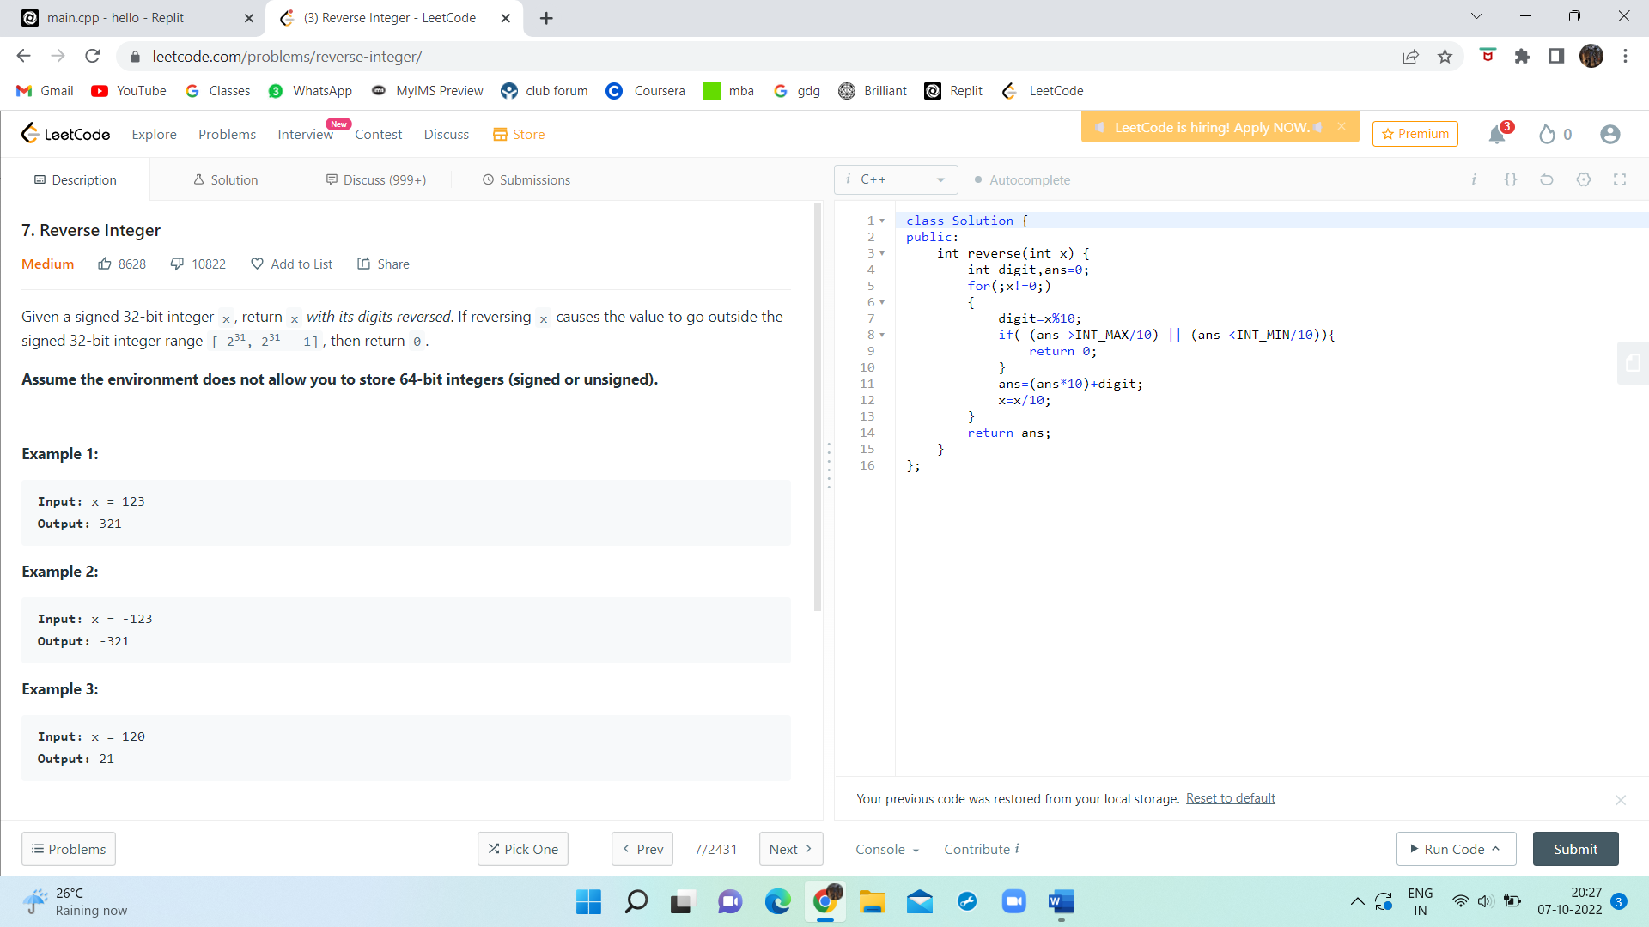
class Solution {
public:
int reverse(int x) {
int digit,ans=0;
for(;x!=0;)
{
digit=x%10;
if( (ans >INT_MAX/10) || (ans <INT_MIN/10)){
return 0;
}
ans=(ans*10)+digit;
x=x/10;
}
return ans;
}
};

